

Figure streaming a song



Figure seeking

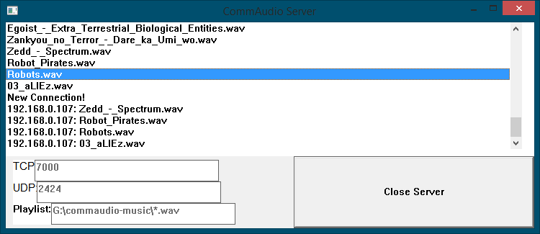

Figure servr showing requestes songs

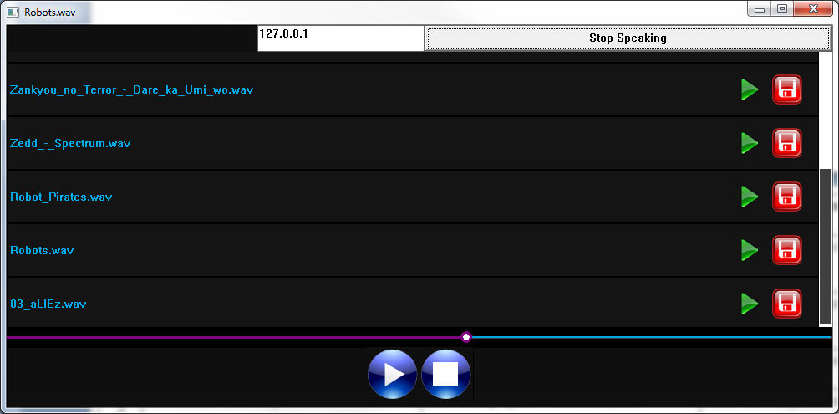

Figure sending voice data

| **Test #** | **Test procedure / description** | **Expected Outcome** | **Actual Outcome & Remarks** | **Pass / Fail** |
| --- | --- | --- | --- | --- |
| 0 | 1. stream a song | The song plays without any screen flickering, at a constant speed | Same as expected | Pass; figure 1 |
| 1 | 1. stream a song 2. seek around in the buffer to different parts of the song | The song being played should seek as well | Same as expected | Pass; figure 2 |
| 2 | 1. select a song to stream | Server will print out the requested song | Same as expected | Pass; figure 3 |
| 3 | Download a song | The song gets downloaded | Same as expected | Pass; |
| 4 | 1. start streaming a song, then pause it | After the song plays for a while, it stops playing, because we press the pause button | Same as expected | Pass |
| 5 | Enter an ip address into the target field, and press start recording to hear the voice on another client | Second client should display text scrolling when executed | Same as expected | Pass; figure 4 |